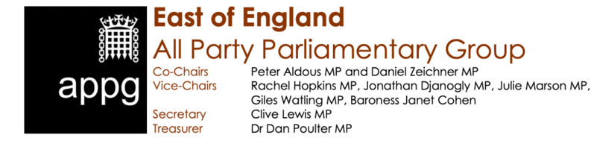

Dear Steve Barclay MP

We are writing to thank you for addressing the East of England APPG last week and to make you aware of a small number of strategic conclusions which we trust will be taken into account by HM Treasury. For your information, we are also sending a similar letter to the Transport Secretary, the Rt Hon Grant Shapps MP.

First, we wanted to welcome your recognition that there are many initiatives underway in the East of England that are consistent with the Government’s wider strategy including levelling up, net zero, and uplift in R&D. In particular Treasury support for Kings Lynn rail investment, the Ely Junction project, efforts to make London Stansted the best-connected airport of all, and two extra stations serving Cambridge, was noted and welcomed. As we have pointed out previously, the East of England as a net contributor to the Exchequer repays investment due to its key strengths as:

- a network of dynamic high growth corridors, linking key regional clusters and institutions, connecting Cambridge with significant coastal assets and global gateways to the east and CaMkOx to the west as well as via the innovation corridor running through Stansted Airport to the London commuter belt in the south

- a global leader in R&D investment, with more people employed in scientific research and development than any other UK region; the East of England has excellent prospects in the increasingly important sectors such as high tech, agri food, bioscience and AI and data

- a frontrunner in contributing to meeting the UK’s net zero carbon target through its potential for innovation and solutions for renewables including offshore wind and nuclear power generation as well as clean growth technology; innovation here will assist the UK’s endeavours towards net zero

Second, and specifically with regards transport, the APPG meeting - which went on to hear from the Chairs of the region’s two Sub-national Transport Bodies and the Mayor of Cambridgeshire and Peterborough as well as the Chief Executive of Haven Gateway and the Chair of the West Anglia Taskforce - has three strategic recommendations:

- future transport investment in the East of England should prioritise improving connectivity between its ports/airports and its major cities/towns as well as those they serve in the Midlands and to the North. This would give maximum productivity gain and also help deliver the net zero ambition.

- that transport investment in the East of England needs to be increased to at least the England average. There has been historical underinvestment due to the way non-metropolitan areas are funded and despite the East of England being a net contributor to HM Treasury. Better physical connectivity would improve productivity considerably.

- that the key to speeding up delivery is to empower and trust the Sub National, and democratically accountable, Transport Bodies and the Cambridgeshire and Peterborough Mayor through longer term (three year) budgets and a strategic statutory remit to decide on and commission improvements

Third, and finally, we would want to re-iterate a number of other points which we believe should also be seriously considered and addressed by the Treasury:

- in a region such as East of England, and especially now in light of how CV19 is impacting on working/commuting patterns, there is an urgent need for much improved digital connectivity.

- coastal communities, including Clacton-on-Sea (where Jaywick is the most deprived neighbourhood of all 32,844 in England), Colchester, Southend, Thurrock, Felixstowe, Great Yarmouth, Ipswich, Lowestoft and Kings Lynn require levelling up support as much as ‘left behind’ towns in the north and midlands

- there is a clear need for a long term and adequate funding boost for local authorities as well as further support and empowerment for them to help deliver both mitigation of covid-19 and the delivery of the recovery the pandemic has precipitated.

We once again thank you for meeting with the East of England APPG, look forward to your reply and invite you to address the Group at some time in the New Year.

Yours sincerely
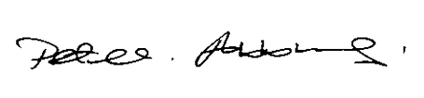

Peter Aldous MP Daniel Zeichner MP
Co-chair Co-chair

The East of England APPG is kindly supported by:

Sent on behalf of the Co-chairs by the Secretariat of the APPG, DevoConnect

