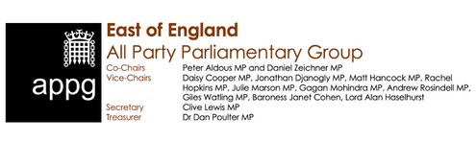

Dear Grant Shapps MP, Secretary of State for Transport

**REALISING THE POTENTIAL OF THE EAST OF ENGLAND’S INTERNATIONAL GATEWAYS**

**THE URGENT NEED FOR INVESTMENT IN ELY AND HAUGHLEY JUNCTIONS**

On Wednesday 25th May 2022 the East of England and UK Innovation Corridor All-Party Parliamentary Groups convened a session entitled **International Gateway: the East of England's Key Role in Global Britain**. This highlighted the fact that with four international airports, including the second busiest in the UK, and thirteen ports, including two freeports, half of the UK’s containerised goods are moved through the region with combined value of £16billion. Please see the attached excellent background briefing that was prepared.

It became apparent during the meeting that improving connectivity to, and between, these ports is absolutely critical in order to realise the potential of the region’s international gateways. It also became clear there are two specific projects that are currently under active consideration for funding which we, as Co-chairs of the East of England APPG, would strongly advocate that the Government does indeed commit to fully support through financial investment – Ely and Haughley Junctions.

*Although there have been some capacity improvements on the Felixstowe Branch Line, capacity constraints around Ely and at Haughley Junction significantly limit the number of freight trains, adding more HGVs to the road and also forcing trains to travel to and from the Midlands via north London.* ***What is specifically needed now is a commitment to fund the next phase of development work for Ely Junction within Control Period 6 and £20million for Haughley Junction so improvement work can begin in 2023.***

We are meeting with Robert Courts, the Ports and Airports Minister, in early July and will raise a number of other issues with him – including the added value of route development at London Stansted Airport, maximising the potential of the region’s ports including two Freeports and the need for the East of England to have, like the North and the Midlands,  an Integrated Rail Plan which brings together various taskforces and includes delivery of East-West Rail.

However , we wanted to urge you now to ***please give special and urgent consideration to the funding of the Ely and Haughley Junction planned improvements***. It is clear that without such critical investment in our transport networks, current challenges will worsen and prevent the region, and country, from reaching its full potential, environmentally, socially, and economically.

As a significant contributor to the UK economy these investments would be good for UK plc as well as for businesses and communities in the East of England. They would also help the Government deliver its ambitions to level up the country, achieve net zero, and drive global Britain forward whilst simultaneously increasing the East of England’s already net contribution to the Treasury.

If you or your officials have any questions please do not hesitate to contact Steve Barwick of the East of England APPG Secretariat who has sent this email on our behalf.

Yours sincerely

cid:image010.png@01D871C6.D41DDDA0

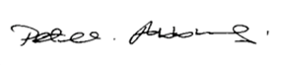

**Peter Aldous MP**                                             **Daniel Zeichner MP                                                         
Co-Chair,                                                            Co-chair,**

**East of England APPG                                     East of England APPG**

*Sent by Steve Barwick – for the East of England APPG Secretariat*

